Software Requirements and Design Document

for

Hotel Management System

Prepared by i220968 M. Raed Sajid and i228810 Gulzar Amin

Nexus Node

27/11/24

Table of Contents

Table of Contents ii

1. Introduction 1

1.1 Purpose 1

1.2 Product Scope 1

1.3 Title 1

1.4 Objectives 1

1.5 Problem Statement 1

2. Overall Description 1

2.1 Product Perspective 1

2.2 Product Functions 2

2.3 List of Use Cases 2

2.4 Extended Use Cases 2

2.5 Use Case Diagram 2

3. Other Nonfunctional Requirements 2

3.1 Performance Requirements 2

3.2 Safety Requirements 2

3.3 Security Requirements 2

3.4 Software Quality Attributes 2

3.5 Business Rules 3

3.6 Operating Environment 3

3.7 User Interfaces 3

4. Domain Model 3

5. System Sequence Diagram 3

6. Sequence Diagram 3

7. Class Diagram 4

8. Package Diagram 4

9. Deployment Diagram 4

# Introduction

## Purpose

The purpose of this document is to specify the software requirements for the **Hotel Management System (HMS)**. This system will automate key operations in a hotel, including room management, customer management, booking management, and payment processing. This document covers the functional, non-functional, and design requirements of the system.

## Product Scope

The **Hotel Management System** will streamline hotel operations by automating tasks such as:

* Managing room availability and reservations.
* Storing and managing customer information.
* Facilitating bookings and check-ins/check-outs.
* Processing payments and generating invoices.

## Title

***Hotel Management System****– An integrated solution for automating hotel operations and enhancing guest experience.*

## Objectives

*The objectives of the HMS are:*

* *To automate and centralize hotel management operations.*
* *To improve customer experience by reducing manual processes.*
* *To ensure data accuracy and availability for better decision-making.*
* *To support seamless integration with payment gateways and reporting tools.*

## Problem Statement

Many hotels still rely on manual or semi-automated systems for managing their daily operations, leading to inefficiencies, errors, and delays. This project aims to develop a comprehensive **Hotel Management System** that will:

* Reduce the time required for booking and check-in/check-out processes.
* Eliminate manual record-keeping and enhance data accuracy.
* Provide a centralized system to manage rooms, customers, and payments efficiently.
* Improve overall operational efficiency and customer satisfaction.

# Overall Description

## Product Perspective

The HMS is a new, standalone product designed to integrate seamlessly with existing hotel infrastructure. It will replace manual processes and paper-based records with a digital, automated solution.  
**System Components:**

* **Frontend (View):** Provides a graphical user interface for staff to interact with the system.
* **Backend (Controller & Model):** Manages business logic and data operations.
* **Database:** Stores information related to customers, rooms, bookings, and payments.

## Product Functions

The HMS will perform the following functions:

* **Room Management:** Add, update, and view room details and availability.
* **Customer Management:** Store and manage customer profiles and contact information.
* **Booking Management:** Create, update, and cancel bookings.
* **Payment Processing:** Accept and process payments, generate invoices.

## List of Use Cases

1. Book a Room
2. Check In and Check Out
3. Send Email Confirmation
4. Manage reservations
5. Billing and payment
6. Provide Feedback
7. Room Maintenance
8. Manage Staff Schedule
9. View Reports
10. Process Payment Details

## Extended Use Cases

## 

## 

## 

## 

## 

## Use Case Diagram

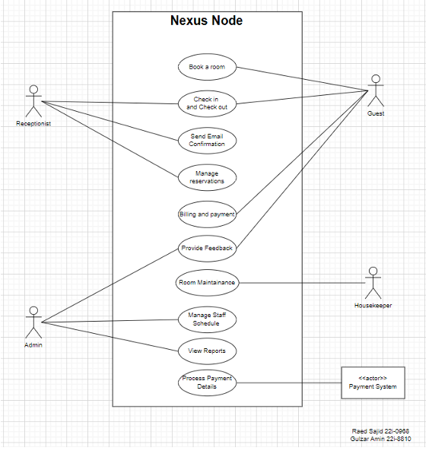

# Other Nonfunctional Requirements

## Performance Requirements

* The system must handle up to **100 concurrent users**.
* Booking operations must be completed within **2 seconds**.
* Database queries must execute within **1 second** for typical operations.

## Safety Requirements

* Data backups must be performed daily.
* The system must provide mechanisms for preventing data loss during power outages or network failures.
* All critical operations (e.g., payment processing) must be logged for audit purposes.

## Security Requirements

* User authentication must be required for accessing the system.
* Sensitive data (e.g., payment information) must be encrypted.
* The system must implement role-based access control to restrict access to certain functions.

## Software Quality Attributes

* **Reliability:** System uptime of **99.9%**.
* **Maintainability:** Modular architecture to facilitate future updates.
* **Usability:** Intuitive user interface with minimal training required.
* **Scalability:** Support for future expansion, including additional hotels or chains.

## Business Rules

* Only authorized staff can access customer data.
* Room bookings cannot be made for dates in the past.
* Payments must be processed before confirming a booking.

## Operating Environment

MySQL and Eclipse JavaFX

## User Interfaces

# Domain Model

## 

# System Sequence Diagram

# Sequence Diagram

## 

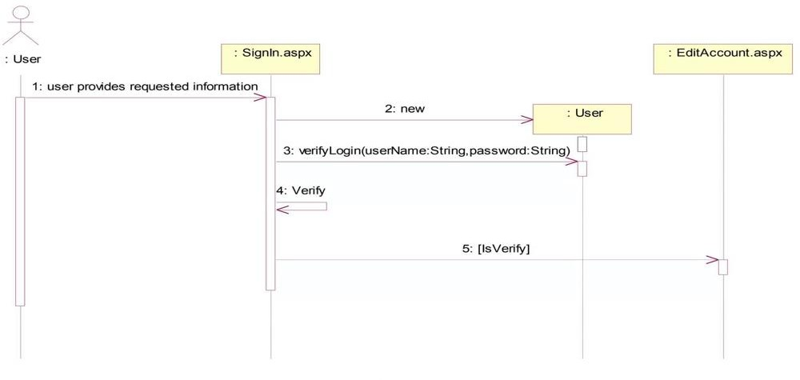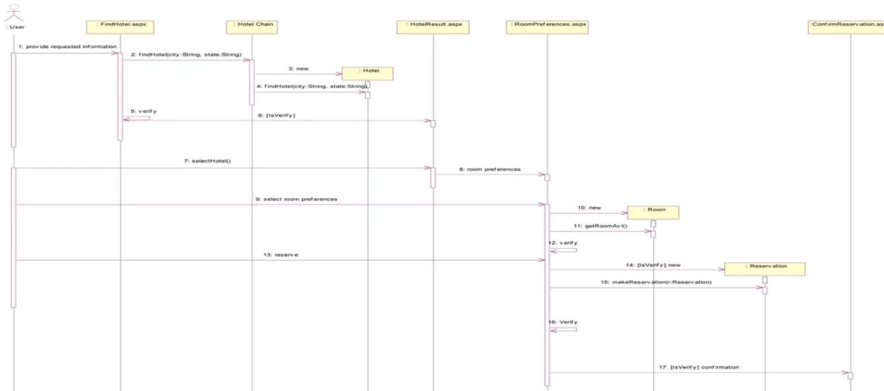

# Class Diagram

# Component Diagram

# Package Diagram

# Deployment Diagram